**COFFEE SHOP SALES- SQL QUERIES**

**CONVERT DATE (transaction_date) COLUMN TO PROPER DATE FORMAT**

SET SQL_SAFE_UPDATES = 0;

UPDATE coffee_shop_sales

SET transaction_date = STR_TO_DATE(transaction_date, '%d-%m-%Y');

**ALTER DATE (transaction_date) COLUMN TO DATE DATA TYPE**

alter table coffee_shop_sales

modify column transaction_date date;

**CONVERT TIME (transaction_time) COLUMN TO PROPER DATE FORMAT**

SET SQL_SAFE_UPDATES = 0;

UPDATE coffee_shop_sales

SET transaction_time = STR_TO_DATE(transaction_time, '%H:%i:%s');

**ALTER TIME (transaction_time) COLUMN TO DATE DATA TYPE**

alter table coffee_shop_sales

modify column transaction_time time;

**DATA TYPES OF DIFFERENT COLUMNS**

desc coffee_shop_sales;

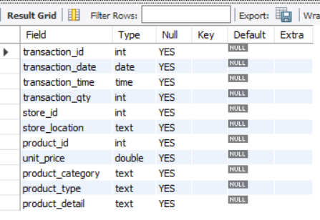

**CHANGE COLUMN NAME `ï»¿transaction_id` to transaction_id**

alter table coffee_shop_sales

change column ï»¿transaction_id transaction_id int;

**TOTAL SALES**

select concat((round(sum(unit_price * transaction_qty)))/1000 ,"K") as Total_Sales

from coffee_shop_sales

where month(transaction_date) = 2; -- feb month

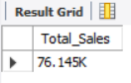

**TOTAL SALES KPI - MOM DIFFERENCE AND MOM GROWTH**

**-- MOM (Month on Month)**

**--** **selected month/current month(CM) = 5 & previous month(PM) = 4**

select

month(transaction_date) as Month, -- no. of month

round(sum(unit_price * transaction_qty)) as Total_Sales,

(sum(unit_price * transaction_qty) - lag(sum(unit_price * transaction_qty),1) -- month sales difference

over(order by month(transaction_date))) / lag(sum(unit_price * transaction_qty),1) -- division by PM

over(order by month(transaction_date)) * 100 as mom_increase_percentage -- percentage

from coffee_shop_sales

where month(transaction_date) in (2,3) -- for month of feb(PM) & March(CM)

group by month(transaction_date)

order by month(transaction_date);

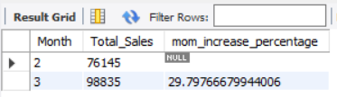

**TOTAL ORDERS**

select count(transaction_id) as Total_Orders

from coffee_shop_sales

where month(transaction_date) = 5; -- May month

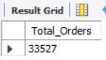

**TOTAL ORDERS KPI - MOM DIFFERENCE AND MOM GROWTH**

select

month(transaction_date) as Month, -- no. of month

round(count(transaction_id)) as Total_Orders,

(count(transaction_id)- lag(count(transaction_id), 1) -- month sales difference

over(order by month(transaction_date))) / lag(count(transaction_id),1) -- division by PM

over(order by month(transaction_date)) * 100 as mom_increase_percentage -- percentage

from coffee_shop_sales

where month(transaction_date) in (4,5) -- for month of Apr(PM) & May(CM)

group by month(transaction_date)

order by month(transaction_date);

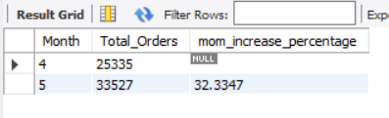

**TOTAL QUANTITY SOLD**

select sum(transaction_qty) as Total_Qty_Solds

from coffee_shop_sales

where month(transaction_date) = 6; -- June month

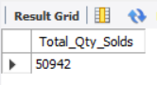

**TOTAL QUANTITY SOLD KPI - MOM DIFFERENCE AND MOM GROWTH**

select

month(transaction_date) as Month, -- no. of month

round(sum(transaction_qty)) as Total_Qty_Solds,

(sum(transaction_qty)- lag(sum(transaction_qty), 1) -- month sales difference

over(order by month(transaction_date))) / lag(sum(transaction_qty),1) -- division by PM

over(order by month(transaction_date)) * 100 as mom_increase_percentage -- percentage

from coffee_shop_sales

where month(transaction_date) in (5,6) -- for month of May(PM) & Jun(CM)

group by month(transaction_date)

order by month(transaction_date);

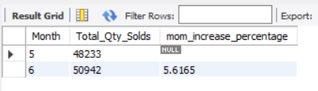

**CALENDAR TABLE – DAILY SALES, QUANTITY and TOTAL ORDERS**

select

concat(round(sum(unit_price * transaction_qty)/1000,1) ,"K") as Total_Sales,

concat(round(count(transaction_id)/1000,1),"K") as Total_Orders,

concat(round(sum(transaction_qty)/1000,1),"K") as Total_Qty_Solds

from coffee_shop_sales

where transaction_date = "2023-03-11"; -- 11 Mar 2023

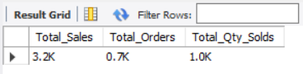

**SALES BY WEEKDAY / WEEKEND:**

select

case when dayofweek(transaction_date) in (1,7) then "Weekend"

else "Wekdays"

end as Day_type,

concat(round(sum(unit_price * transaction_qty)/1000,1),'K') as Total_Sales

from coffee_shop_sales

where month(transaction_date) = 3 -- Mar month

group by case when dayofweek(transaction_date) in (1,7) then "Weekend"

else "Wekdays"

end

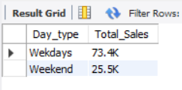

**SALES BY STORE LOCATION**

select

store_location,

concat(round(sum(unit_price * transaction_qty)/1000,2),'k') as Total_Sales

from coffee_shop_sales

where month(transaction_date) = 6 -- Jun Month

group by store_location

order by sum(unit_price * transaction_qty) desc;

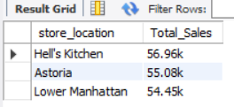

**SALES TREND OVER PERIOD**

select

concat(round(avg(Total_Sales)/1000,2),'K') as Avg_Sales

from

(

select sum(unit_price * transaction_qty) as Total_Sales

from coffee_shop_sales

where month(transaction_date) = 4 -- Apr month

group by transaction_date

) as Inner_query;

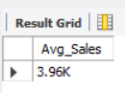

**DAILY SALES FOR MONTH SELECTED**

select

day(transaction_date) as Day_of_month,

round(Sum(unit_price * transaction_qty),2) as Total_Sales

from coffee_shop_sales

where month(transaction_date) = 5 -- May month

group by transaction_date

order by transaction_date;

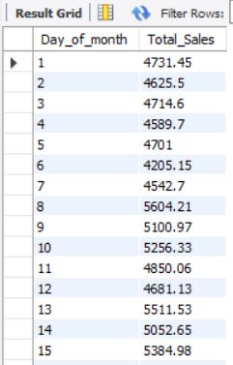 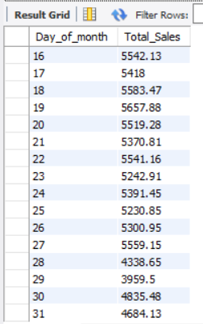

**COMPARING DAILY SALES WITH AVERAGE SALES – IF GREATER THAN “ABOVE AVERAGE” and LESSER THAN “BELOW AVERAGE”**

select Day_of_month,

case when total_sales > avg_sales then "Above Average"

when total_sales < avg_sales then "Below Average"

else "Average"

end as Sales_Status, total_sales

from

(

select

day(transaction_date) as Day_of_Month,

round(sum(unit_price * transaction_qty),2) as Total_Sales,

avg(sum(unit_price * transaction_qty)) over () as Avg_Sales

from coffee_shop_sales

where month(transaction_date) = 3 -- Mar month

group by day(transaction_date)

) as sales_data

order by Day_of_Month;

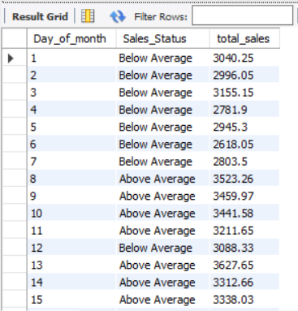 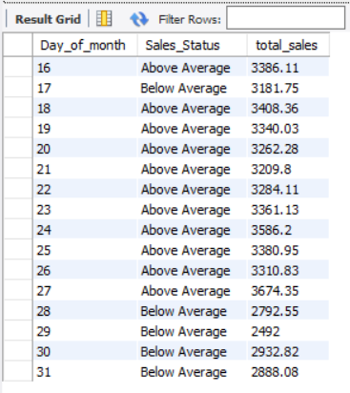

**SALES BY PRODUCT CATEGORY**

select

product_category,

round(sum(unit_price * transaction_qty),2) as Total_sales

from coffee_shop_sales

where month(transaction_date) = 1

group by product_category

order by sum(unit_price * transaction_qty) desc;

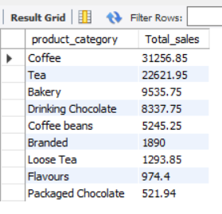

**SALES BY PRODUCTS (TOP 10)**

select

product_type,

round(sum(unit_price * transaction_qty),2) as Total_sales

from coffee_shop_sales

where month(transaction_date) = 5 and product_category = 'Coffee'

group by product_type

order by sum(unit_price * transaction_qty) desc limit 10;

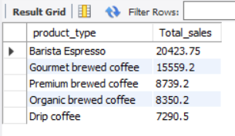

**SALES BY DAY | HOUR**

select

round(sum(unit_price * transaction_qty),2) as Total_Sales,

sum(transaction_qty) as Total_Qty,

count(*) as Total_orders

from coffee_shop_sales

where dayofweek(transaction_date) = 2 -- Monday

and month(transaction_date) = 5 -- Mar month

and hour(transaction_time) = 8 -- Hours no 8

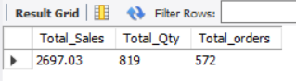

**TO GET SALES FOR ALL HOURS FOR MONTH OF MAY**

select

hour(transaction_time) as Hour_of_day,

round(sum(unit_price * transaction_qty),2) as Total_sales

from coffee_shop_sales

where month(transaction_date) = 2 -- Feb month

group by hour(transaction_time)

order by hour(transaction_time);

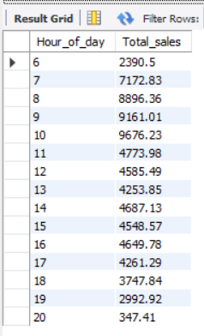

**TO GET SALES FROM MONDAY TO SUNDAY FOR MONTH OF MAY**

select

case

when dayofweek(transaction_date) = 2 then 'Monday'

when dayofweek(transaction_date) = 3 then 'Tuesday'

when dayofweek(transaction_date) = 4 then 'Wednesday'

when dayofweek(transaction_date) = 5 then 'Thursday'

when dayofweek(transaction_date) = 6 then 'Friday'

when dayofweek(transaction_date) = 7 then 'Saturday'

else 'Sunday'

end as Day_of_Week,

Round(sum(unit_price * transaction_qty)) as Total_sales

from coffee_shop_sales

where month(transaction_date) = 4 -- Apr month

group by case

when dayofweek(transaction_date) = 2 then 'Monday'

when dayofweek(transaction_date) = 3 then 'Tuesday'

when dayofweek(transaction_date) = 4 then 'Wednesday'

when dayofweek(transaction_date) = 5 then 'Thursday'

when dayofweek(transaction_date) = 6 then 'Friday'

when dayofweek(transaction_date) = 7 then 'Saturday'

else 'Sunday'

end;

